From: http://www.science20.com/the_conversation/consensus_on_consensus_97_of_climate_scientists_say_climate_scientists_are_right_on_global_warming-170664

Consensus On Consensus: 97% Of Climate Scientists Say Climate Scientists Are Right On Global Warming
By The Conversation | April 17th 2016 08:49 AM | 7 comments | Print | E-mail | Track Comments
["The Conversation is an independent source of news and views, funded by the academic and research community and delivered direct to the public. The Conversation launched in Australia in March 2011. " In 2019, the original article is reported to be here: https://theconversation.com/consensus-confirmed-over-90-of-climate-scientists-believe-were-causing-global-warming-57654 and also here https://iopscience.iop.org/article/10.1088/1748-9326/11/4/048002 -FNC]
When we published a paper in 2013 finding 97% scientific consensus on human-caused global warming, what surprised me was how surprised everyone was. [The author of these words appears to be John Cook, principal author of the famous “97.2% paper, The 2012 AGW Consensus study. Regardless, he can be seen and heard in the video referenced a few paragraphs farther down!]
Ours wasn’t the first study to find such a scientific consensus. Nor was it the second. Nor were we the last.
Nevertheless, no-one I spoke to was aware of the existing research into such a consensus. Rather, the public thought there was a 50:50 debate among scientists on the basic question of whether human activity was causing global warming.
This lack of awareness is reflected in a recent pronouncement by Senator Ted Cruz (currently competing with Donald Trump in the Republican primaries), who argued that:
The stat about the 97% of scientists is based on one discredited study.
Why is a US Senator running for President attacking University of Queensland research on scientific agreement? Cruz’s comments are the latest episode in a decades-long campaign to cast doubt on the scientific consensus on climate change.
Back in 2002, a Republican pollster advised conservatives to attack the consensus in order to win the public debate about climate policy. Conservatives complied. In conservative opinion pieces about climate change from 2007 to 2010, their number one argument was “there is no scientific consensus on climate change”.
Recent psychological research has shown that the persistent campaign to confuse the public about scientific agreement has significant societal consequences. Public perception of consensus has been shown to be a “gateway belief”, influencing a range of other climate attitudes and beliefs.
People’s awareness of the scientific consensus affects their acceptance of climate change, and their support for climate action.
The psychological importance of perceived consensus underscores why communicating the 97% consensus is important. Consensus messaging has been shown empirically to increase acceptance of climate change.
And, crucially, it’s most effective on those who are most likely to reject climate science: political conservatives.
In other words, consensus messaging has a neutralizing effect, which is especially important given the highly polarized nature of the public debate about climate change.

Expert agreement
Consequently, social scientists have urged climate scientists to communicate the scientific consensus, countering the misconception that they are still divided about human-caused global warming.
But how do you counter the myth that the 97% consensus is based on a single study?
One way is to bring together the authors of the leading consensus papers to synthesize all the existing research: a meta-study of meta-studies. We did exactly that, with a new study published in Environmental Research Letters featuring authors from seven of the leading studies into the scientific consensus on climate change. [dated 28 April, 2015.]
Watch this Video! Starting at 46 seconds, it shows John Cook, unrepentant, saying that His famous study wasn’t the only study on concensus and that they all basically agreed! Online, the label on this is: A video summary of the new paper into climate change consensus. (2016)
A recurring theme throughout the consensus research was that the level of scientific agreement varied depending on climate expertise. The higher the expertise in climate science, the higher the agreement that humans were causing global warming.
To none of our surprise, the highest agreement was found among climate scientists who had published peer-reviewed climate research. [The famous 2013 John Cook study used nothing but these expert experts – in both phases. –FNC] Interestingly, the group with the lowest agreement was economic geologists.
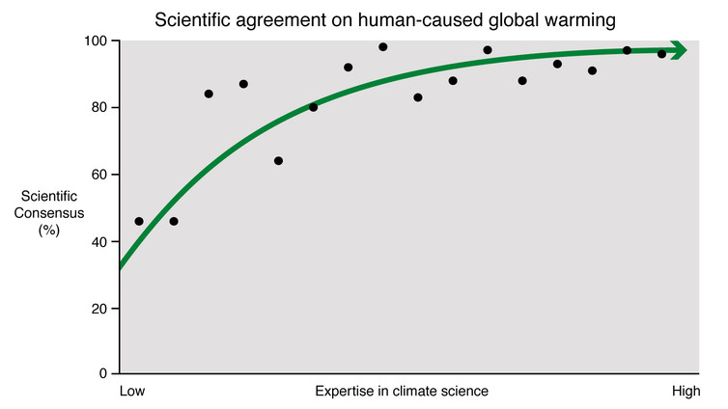
Expertise vs consensus. Skeptical Science
Seven studies quantified the level of agreement among publishing climate scientists, or among peer-reviewed climate papers. Across these studies, there was between 90% to 100% agreement that humans were causing global warming.
A number of studies converged on the 97% consensus value. [4 out of 7, in fact.] This is why the 97% figure is often invoked, having been mentioned by such public figures as President Barack Obama, Prime Minister David Cameron and US Senator Bernie Sanders.
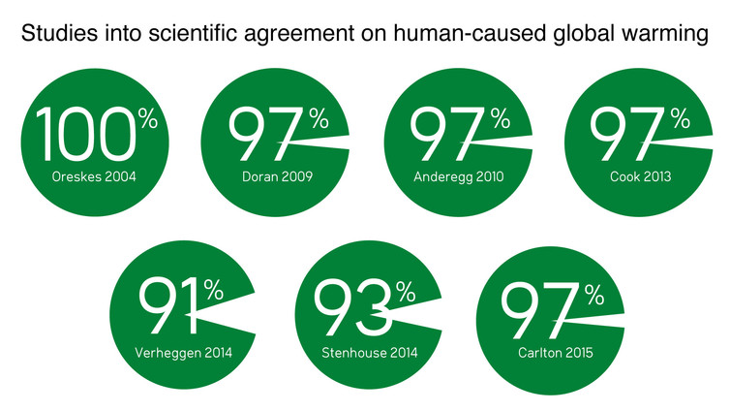
Studies into consensus. Skeptical Science

Manufacturing doubt about consensus
The relationship between scientific agreement and expertise turns out to be crucially important in understanding the consensus issue. Unfortunately, it provides an opportunity for those who reject human-caused global warming to manufacture doubt about the high level of scientific agreement.
They achieve this by using groups of scientists with lower expertise in climate science, to convey the impression that expert agreement on climate change is low. This technique is known as “fake experts”, one of the five characteristics of science denial.
For example, surveys of climate scientists may be “diluted” by including scientists who don’t possess expertise in climate science, thus obtaining a lower level of agreement compared to the consensus among climate scientists. This is partly what Senator Rick Santorum did when he argued that the scientific consensus was only 43%.
Another implementation of the “fake expert” strategy is the use of petitions containing many scientists who lack climate science credentials. The most famous example is the Oregon Petition Project, which lists over 31,000 people with a science degree who signed a statement that humans aren’t disrupting the climate. However, 99.9% of the signatories aren’t climate scientists.
The science of science communication tells us that communicating the science isn’t sufficient. Misinformation has been shown to cancel out the effect of accurate scientific information. We also need to explain the techniques of misinformation, such as the “fake expert” strategy.
This is why in communicating the results of our latest study, we not only communicated the overwhelming scientific agreement. We also explained the technique used to cast doubt on the consensus.
By John Cook, Climate Communication Research Fellow, Global Change Institute, The University of Queensland. This article was originally published on The Conversation. Read the original article.
The Conversation
MORE ARTICLES
- Consensus On Consensus: 97% Of Climate Scientists Say Climate Scientists Are Right On Global Warming
- Why Athletes Spit Out Sports Drinks Instead Of Swallowing
- Give Me Your Tired, Your Poor, Your...Nuclear Waste?
All Articles
ABOUT
The Conversation is an independent source of news and views, funded by the academic and research community and delivered direct to the public. The...
View Profile

RELATED ARTICLES ON SCIENCE 2.0
- Consensus On Consensus
- Sea Level Rise In Western Tropical Pacific Will Be Caused By Man
- Hard Of Thinking: If You're Bad At Logic, Logically You Would Never Know
- Fire, Ice And Invasion
- There Is Scientific Consensus On Anthropogenic Climate Change Among Climate Scientists

by Taboola
Sponsored Links
You May Like

Cyber Blowout. KitchenAid Mixers Going for Next to NothingQuiBids

Boston Homeowners Are Furious With Their Power CompanyHome Solar Programs

20 Unforgettable Photos Of Environmental PollutionGeekVIP

COMMENTS
It looks as if you, and every other alarmist, have used nearly every method demonstrated in the short but humorous book called "How To Lie With Statistics" by Darrell Huff. I highly recommend it.
http://www.horace.org/blog/wp-content/uploads/2012/05/How-to-Lie-With-St...
surveys of climate scientists may be “diluted” by including scientists who don’t possess expertise in climate science, thus obtaining a lower level of agreement compared to the consensus among climate scientists.
The reason those opinions by "scientists who don’t possess expertise in climate science" are still valid is that you don't need to be a climate scientist to recognize the unscientific methods and the manipulation of the data sets in order to produce the results favorable to your expected results, consciously or unconsciously. Very unscientific indeed.
According to predictions from just a few years ago New York City and most of florida were supposed to be under water today. ALL of the climate models have failed to produce our current climate. Sorry, I've some news for you; When ALL of the models have failed to predict reality YOUR SCIENCE IS FLAWED!
Secondly, when you insist on allowing only the statistics and opinions from a closed group of people your statistics will inevitably be skewed in favor of the majority beliefs of that group. For instance if you survey a group of Catholics by asking them if they believe in God and get a 97% response, indicating that they do, that statistic does NOT translate to the rest of the population.
What percent of the very narrow minded closed group of climate scientists are actually died-in-the wool idealist liberals with an anti-capitalistic bend, my guess is probably somewhere about 97%. Can you now see how ridiculous the 97% argument is? My guess is probably not since, as with climate change, we are not talking about science, truth, or reality. In fact, we are actually discussing mainly religion and group think and leftist subterfuge.
It takes a village to raise an idiot.
PhotoDady (not verified) | 04/17/16 | 11:48 AM
- Reply to This »

- Link
Climate change is not a process that happens over night, but something that is provoked in a long period of time and that has consequences over a large period of time. Everybody is preoccupied by the climate change, but it is useless to discuss only the future without understanding the main cause of the climate transformation. If you look at the past 170 years, there are many human actions that influenced climate. Human oceanic activity (sailing, navigation, warfare, offshore wind parks, fisheries etc) has its influence on the oceans and they have their influence on the climate. We cannot say that the climate would have been the same if we weren't here. It's important for people to understand that our impact is changing everything.....for good or for worse. For example, you may take a look here (http://1ocean-1climate.com/) and see how oceans are influencing our climate and how our actions over the oceans are also influencing climate.
Lowry Dave (not verified) | 04/17/16 | 12:47 PM
- Reply to This »

- Link
We cannot say that the climate would have been the same if we weren't here.
Precisely.
There is absolutely no hard tangible evidence, that exists anywhere, proving any level of causation that human activity has actually caused any measurable amount of influence upon our Earth's overall climate. There is, however, a distinct correlation that proves natural temperature fluctuations are actually the cause for CO2 levels to vary.
For instance, I can take a pee into the ocean and say with a nearly 100% confidence level that I had an influence on worldwide ocean levels, however, I highly doubt that those levels would, in no way, actually be measurable. In other words there would be no measurable statistical correlation and therefore no statistical causation.
Again, read the book "How to Lie With Statistics" linked to in the first post in this thread.
Photodady (not verified) | 04/17/16 | 20:03 PM
- Reply to This »

- Link
The IPCC must be held accountable for their blatant and unfounded fear mongering!
I intend to sue them for fraud and make them fessup in court.
Can anyone offer any guidance on how to proceed?
Rod (not verified) | 04/17/16 | 13:58 PM
- Reply to This »

- Link
Watching this from the side.
One thing that is not clearly done in the article is exactly what question was asked. If the question were 'have human activities affected climate', even among 'skeptics' you'd probably get a large response of 'yes'. If the question were 'have human activities tossed us into an apocalyptic path that can only be addressed by discarding the huge benefits to human life in the past 100 years', the results might be quite different.
jay (not verified) | 04/18/16 | 12:05 PM
- Reply to This »

- Link
One thing that is puzzling, of 7 studies referenced, 4 of them just happen to be 97%. Seems a bit odd.
jay (not verified) | 04/18/16 | 12:09 PM
- Reply to This »

- Link
"puzzling" NOT!
The 97% argument is nothing more than Leftist subterfuge. Actually the initial 97% argument came from the first IPCC report sent out to would be sycophants. The remarkable thing is how in the hell did they not get a 100% response? Since the only people who were allowed into the inner AGW circle were people who had committed themselves to human caused global warming in the first place.
Actually there were about one thousand reports sent out and only about one hundred responded, of these 100 roughly 97 agreed with the assertions. In actuality 900 + 3 polled either disagreed or did not find valuable their time worthy of response. To translate this ridiculous statistical figure, when you include the entire sample, the actual figure is 9.7%, laughable at best.
Again PLEASE read "How to Lie With Statistics" at the link provided in the first response in this thread. I'm sure you will recognize every lie used by the leftist alarmists, it's actually quite laughable, if only it weren't so damn serious.
PhotoDady (not verified) | 04/18/16 | 22:31 PM
- Reply to This »

- Link

Two studies actually. You can use the telltale percentages to know which if being talked about. Phase 1 touts 97.1% concensus while the Phase 2 study concludes that the new better number is instead 97.2%.

